Recursion: https://www.geeksforgeeks.org/introduction-to-recursion-2/

Problem:
https://www.geeksforgeeks.org/problems/factorial5739/1
C++
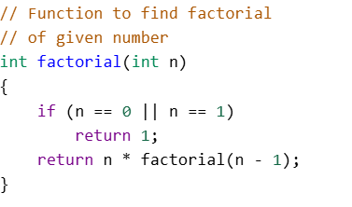
Java:
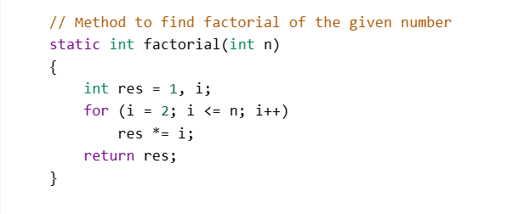
Python:
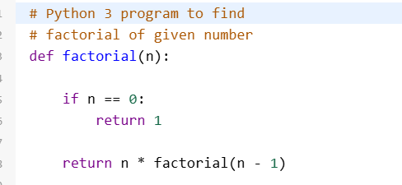

Problem:https://www.geeksforgeeks.org/problems/nth-fibonacci-number1335/1
C++
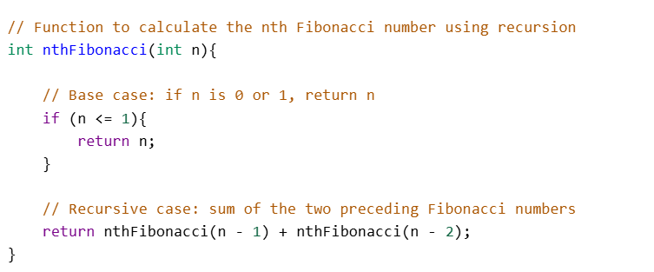
Java:
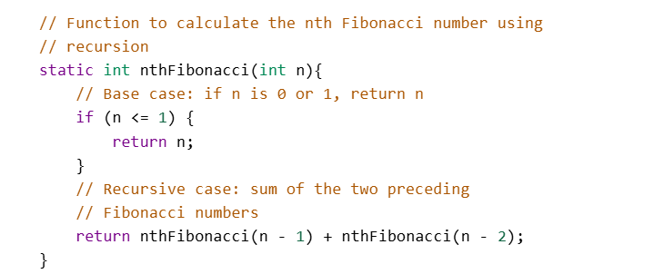
Python:
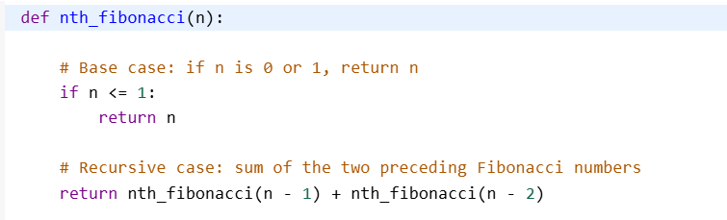
Problem:https://www.geeksforgeeks.org/problems/print-1-to-n-without-using-loops3621/1

C++
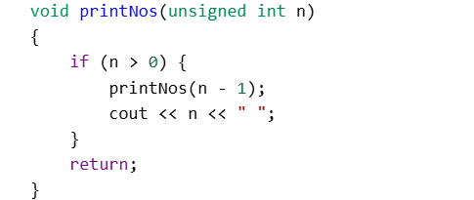
Java:
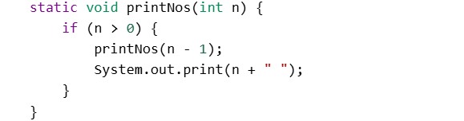
Python:
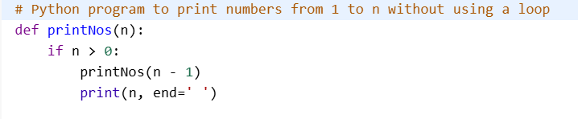

Problem: https://www.geeksforgeeks.org/problems/powx-n/1
C++
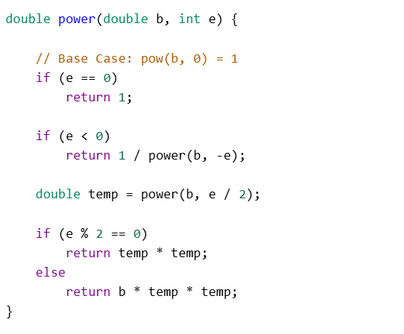
Java:
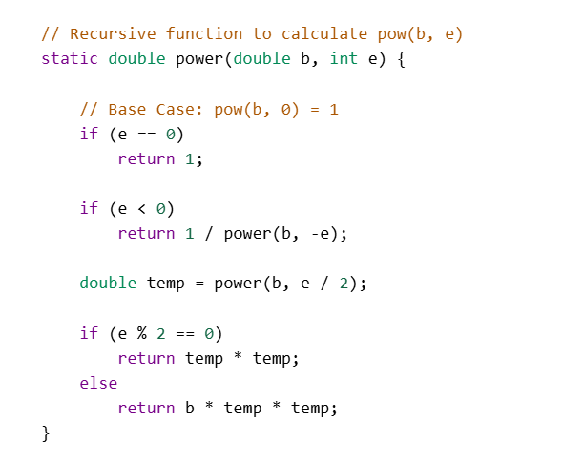
Python:
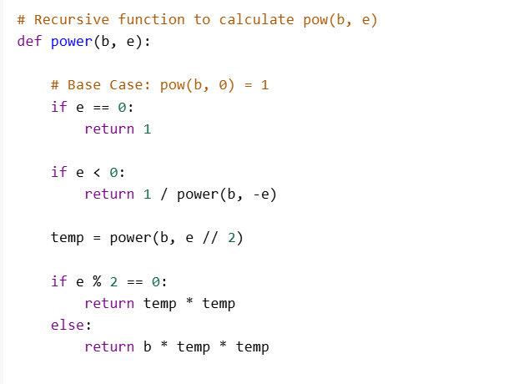

Problem:
https://www.geeksforgeeks.org/problems/palindrome-string0817/1
C++
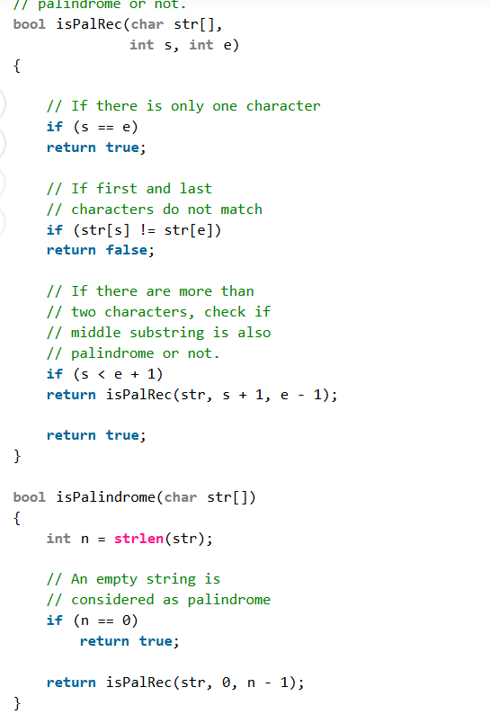

Java:
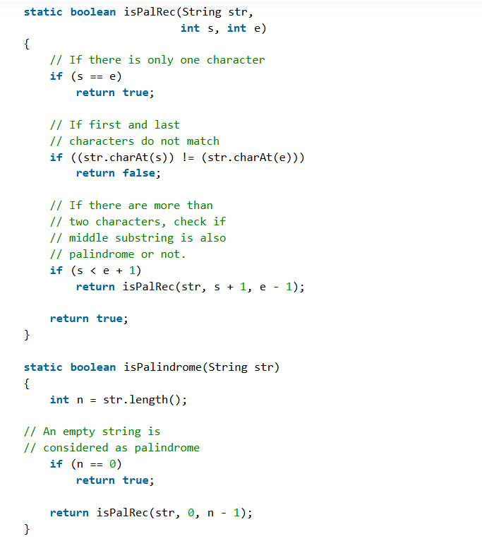

Python:
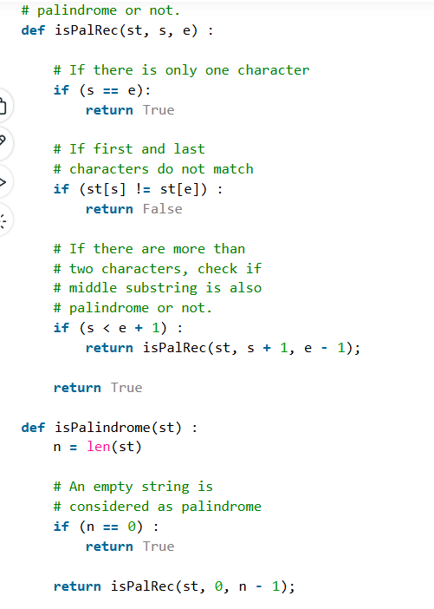

Problem: https://www.geeksforgeeks.org/problems/rat-in-a-maze-problem/1

C++
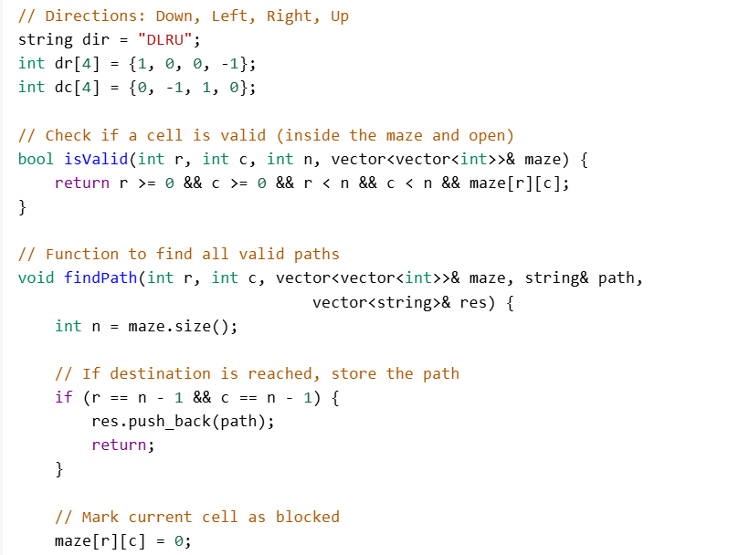
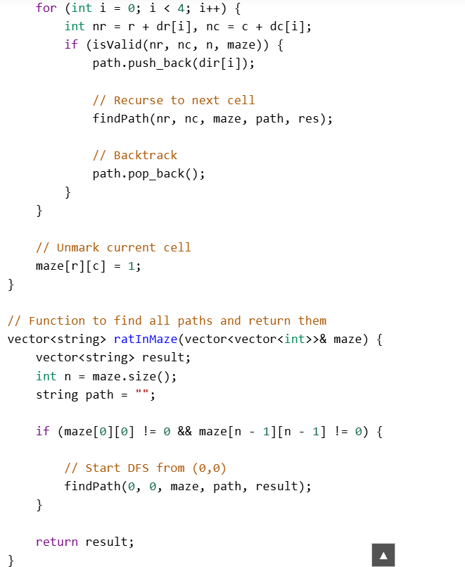

Java:
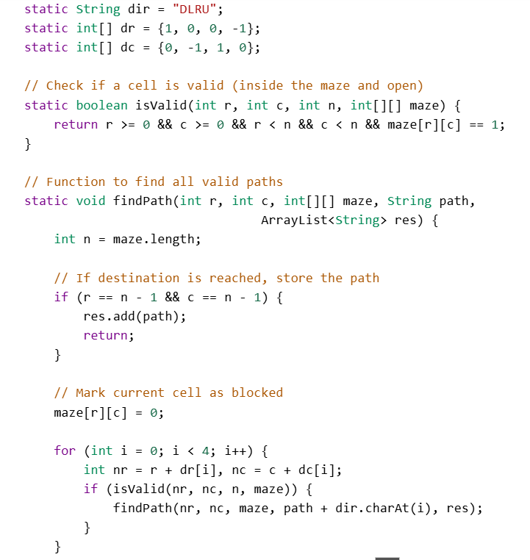
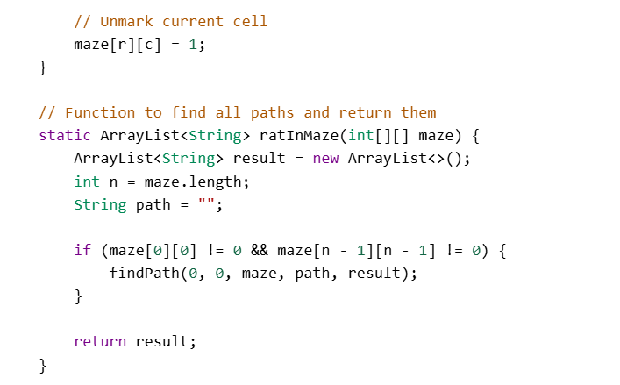

Python:
